A-Team Tutorials

1.2 Visibility and Missions

# Visibility

Now it is time to make a final decision on which object you are going to target, obtain its exact coordinates, set up the missions and (weather willing!) a few hours later download the results.

## JPL Horizons or MPC?

You need to get detailed information about an object’s visibility to the Slooh telescopes. Some Slooh members may already be familiar with using [JPL Horizons](http://ssd.jpl.nasa.gov/horizons.cgi) to obtain this data. There is no reason why they should not continue to do so if they find that system easier to use. However, it may be worth learning to use the MPC (Minor Planet Centre) Ephemeris pages (described below) because:

* You can copy and paste a plain text candidates list directly into the selection page.
* You can get information for all your candidates at the same time.
* You get information about whether new observations are needed and the uncertainty of the position.
* All the information needed to assess the viability of a mission is immediately available.

The [MPC Site](http://www.minorplanetcenter.net) has many pages and navigating within the site can be complicated. For Level 1 you will only need to select [Observers/Ephemeris Service](https://minorplanetcenter.net/iau/MPEph/MPEph.html) but it is worth spending a bit of time exploring other parts of the site as they will be needed in due course.

## Ephemeris

“Ephemeris” is a fancy word for a list showing the coordinates of an object at different times.

At this stage I am assuming you have a selection of objects in a candidates list, and you know what missions are available for one of the Slooh Telescopes. Go to the [MPC Ephemeris page](http://www.minorplanetcenter.net/iau/MPEph/MPEph.html), enter the candidates list into the objects box (you can copy and paste the entire list into the box as long as it just contains object names, numbers or designations each on a separate line.)

The MPC will recognise an object in several ways:

* For an un-numbered object use its Provisional Designation (e.g., 2014 ER48).
* For a numbered object use its number (e.g., 12711), its name (e.g., Tukmit) or the Provisional Designation it had before it received a number (e.g., 1991 BB). 12711, Tukmit and 1991 BB all refer to the same object.

Elsewhere on the Ephemeris page:

* Make sure “Return Ephemeris” is selected as the option.
* Enter ephemeris start date/time (e.g., 2018 12 26 22:00).
* Enter Number of dates to output (say 18).
* Enter Ephemeris Interval and select units (say 30, minutes).
* Enter Observatory code (G40 for Slooh at Teide or W88 for Chile).

Leave other fields as default and press “Get ephemerides/HTML page”. You will see something like the page below for each object in the candidates list.

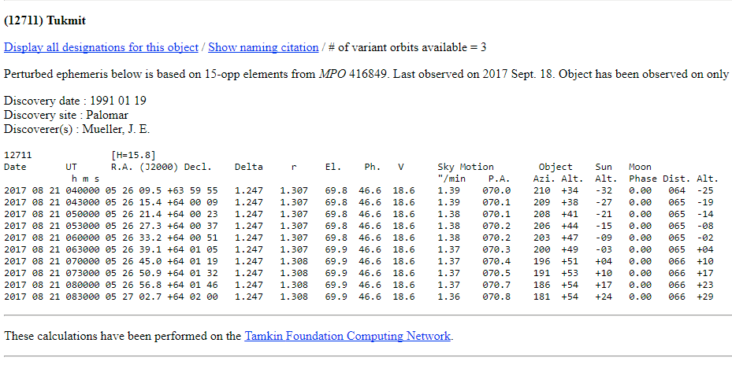

*Ephemeris for Tukmit*

The page shows the number and name (or Provisional Designation), information about when it was discovered and last observed, comments about whether more observations are required and a table of times and coordinates.

There are several things to check:

* Check “V” (magnitude). Anything brighter than about 17.0 should give you an easy target for measurement.
* Check “Object Alt.” (altitude above the horizon). Go for objects that are above 40 degrees from the horizon at the time of the mission. Closer to the horizon and haze or atmospheric disturbance can reduce the quality of images.
* Check “Sky motion “/min”. Fast objects will leave faint trails and will be difficult to measure. Ideally the object should not move more than about 2 or 3 pixels during the exposure. In practice speeds up to around 3”/min are fine for T2WF and C2WF or 5”/min for T1HM.
* Check the Moon. Phase (a percentage of full), Alt (distance above the horizon) and Dist. (angular distance between the object and the Moon). For a full Moon I would want to be 90° away from the Moon and at first/last quarter 60° away. Slooh will not allow a reservation if it thinks the Moon is too close.

For information:

* “Delta” is the object’s distance from Earth in AU.
* “r” is the object’s distance from the Sun in AU.
* “El.” is “elevation”, the angular distance of the object from the Sun.
* “Ph” is “phase” that specifies the percent illumination of the object (like a Moon phase).
* There may be additional information on the right of the table showing Uncertainty. This is included if the position of the object is unsure (this will be important later in the Tutorial).

The R.A. and Decl columns tell you where the object should be at different times. Keep the ephemeris page open while you look for suitable mission times.

# Missions

When you have an object that satisfies all your criteria, reserve the missions.

You should use the T1HM, T2WF or C2WF systems for your missions. When it comes to measurement you will want at least three images spread out over half-an-hour or more to see that the object has moved. Schedule the missions spread 10-20 minutes apart. Select the mission times and get the coordinates from the ephemeris.

* Remember you can “hold” missions on the Slooh reservation system so look through the available slots, decide on the set of missions you want and “hold” them until you are ready to finalise them.

If you have scheduled missions spread over an hour or so your object will not move far across the field of view. It is best to set all the missions using the coordinates where the object will be half-way through your group of missions. That way all the images will align together showing the same field of view and the object will appear to move through the centre of the images when you “blink” them later. This will also reduce the effect of any defects in the CCD as different pixels will be showing the object in each mission.

Enter the coordinates into the Slooh reservation slots. We normally use the Multi-Luminance 50s processing recipe for asteroid hunting as this gives multiple 50-second luminance images for each mission. Multi-Luminance 20s can be used for fast objects, and we will be using that later in the tutorial.

# Retrieve the FITS

FITS (Flexible Image Transport System) files contain detailed information from the camera. This high precision data is needed to make accurate measurements of position and magnitude. FITS files are generated over a period of hours after the end of missions each night.

In the Slooh Desktop, go to My Past Missions and check that your missions ran OK. Select “view mission log”. When the FITS files are available a FITS button will appear. Click on that button for a list of FITS Files available. You will be interested in the files generated by the T1HM, T2WF or C2WF cameras.

Select the download symbol for each of the required FITS files. The files will appear in your Downloads folder. It’s a good idea to set up a hierarchy of folders for your FITS files, notes and measurements because you will collect a great many of them eventually. Set up a folder to hold your images of this object and move the FITS into it.

### Filenames

Filenames of FITS files look like this:

112356m055032_20140406_213041_0_abcdef_l_cal.fit

112356m055032_20140406_213341_3_abcdef_r_cal.fit

The filenames are made up of the following parts:

* The coordinates of the mission: RA=11h 23m 56s, Decl= -05° 50′ 32”. If the Dec is positive, then the “m” will be a “p”. These are the coordinates used to plan the mission they are only an approximation of where the telescope was pointing. The precise coordinates of the centre of the image will be measured by Astrometrica and will be slightly different.
* The date (yyyymmdd): 2014 04 06 and the time (hhmmss): 21:30:41 or 21:33:41. This is the timestamp from when the image file was created and is not a precise indicator of the time the exposure happened. The start of the exposure is contained in “FITS Header” information embedded within the file.
* A sequence number of images within the mission.
* A “random” 6-character string to ensure the name is unique.
* A letter indicating which filter was used:
  + l – luminance.
  + r – red.
  + g – green.
  + b – blue.
  + e – photometric visual.
  + d – photometric infrared.
  + v – photometric red.
* “cal” indicates the image has been calibrated.
* “.fit” is the file type

If you have used the Multi-luminance recipe you may get several “l” images, but you only need one for now. If you used the Generic recipe there will be one “l” image and we will use that for measurement.

Now you have your FITS files you can proceed to process them in Astrometrica.

*First published April 2014. Last update 22 Mar 2024.*

*Tony Evans*